Cloud Computing Lab Eval Missed

Project Report : Cloud Article Deployment on Amazon EKS

NAME : Sricharan A
CLASS : CSE – H
ROLL : CB.SC.U4CSE23764

Project Overview:
This project demonstrates my practical implementation of containerizing and deploying a web-based news article focused on "Cloud Computing" using highly scalable cloud infrastructure on Amazon Web Services (AWS). I built this to showcase my understanding of modern cloud architectures.

Prerequisites:
1.AWS CLI
2.Docker Desktop
3.kubectl
4.eksctl

Configure AWS Credentials :
1. Log in to your AWS Academy Learner Lab.
2. Click on AWS Details to reveal your temporary credentials.

“aws_access_key_id=YOUR_ACCESS_KEY aws_secret_access_key=YOUR_SECRET_KEY aws_session_token=YOUR_SESSION_TOKEN”

Application Containerization:
- Create the Frontend Code, Create a file named index.html with your web content
- Create the Dockerfile In the same directory as index.html, create a file exactly named Dockerfile:

“FROM nginx:alpine COPY index.html /usr/share/nginx/html/index.html EXPOSE 80 CMD ["nginx", "-g", "daemon off;"]”

- Build the Docker Image Run the following command in your terminal to build the image tagged as cloud-news-frontend:

“docker build -t cloud-news-frontend”

Push to Amazon Elastic Container Registry (ECR) :

- Create an ECR Repository Create a repository in AWS to hold your Docker image:

“aws ecr create-repository --repository-name cloud-news-frontend --region us-east-1”

- Authenticate Docker with ECR

“aws ecr get-login-password --region us-east-1 | docker login --username AWS --password-stdin YOUR_ACCOUNT_ID.dkr.ecr.us-east-1.amazonaws.com”

- Tag and Push the Image Tag your local image to match the remote ECR repository, then push it:

“docker tag cloud-news-frontend:latest YOUR_ACCOUNT_ID.dkr.ecr.us-east-1.amazonaws.com/cloud-newsfrontend:latest docker push YOUR_ACCOUNT_ID.dkr.ecr.us-east-1.amazonaws.com/cloud-news-frontend:latest”

Create the Amazon EKS Cluster:

- You cannot use standard eksctl commands because you lack the permissions to create new IAM roles. You MUST use the pre-existing LabRole.
Create a configuration file named cluster.yaml:

“apiVersion: eksctl.io/v1alpha5 kind: ClusterConfig metadata: name: cloud-project-cluster region: us-east-1 version: "1.30" iam: serviceRoleARN: "arn:aws:iam::YOUR_ACCOUNT_ID:role/LabRole" managedNodeGroups: - name: standard-nodes instanceType: t3.medium minSize: 1 maxSize: 3 desiredCapacity: 2 iam: instanceRoleARN: "arn:aws:iam::YOUR_ACCOUNT_ID:role/LabRole" “

- Run the following command to build the VPC and the EKS cluster:
“eksctl create cluster -f cluster.yaml”

Kubernetes Deployment:

- Create Kubernetes Manifests Create a file named k8s-deploy.yaml. Make sure to replace YOUR_ACCOUNT_ID!

“apiVersion: apps/v1
kind: Deployment
metadata:
name: cloud-news-frontend
spec:
replicas: 2
selector:
matchLabels:
app: cloud-news
template:
metadata:
labels:
app: cloud-news
spec:
containers:
- name: frontend
image: YOUR_ACCOUNT_ID.dkr.ecr.us-east-1.amazonaws.com/cloud-news-frontend:latest
ports:
- containerPort: 80
---
apiVersion: v1
kind: Service
metadata:
name: cloud-news-service
spec:
type: LoadBalancer
selector:
app: cloud-news
ports:
- protocol: TCP
port: 80
targetPort: 80”

- Deploy the Details Apply the manifests to your cluster:

“kubectl apply -f k8s-deploy.yaml”

- Verify and Access the Application Check if the pods are running:

“kubectl get pods”

- Get the public URL (External-IP) of the LoadBalancer:

“kubectl get services cloud-news-service”

AWS Services Used :

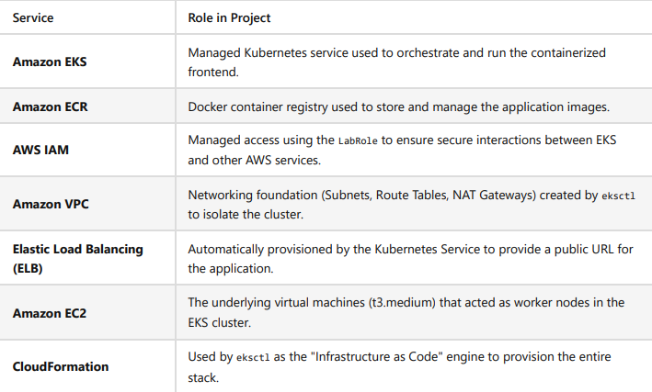

Project Screenshots :

Cluster :

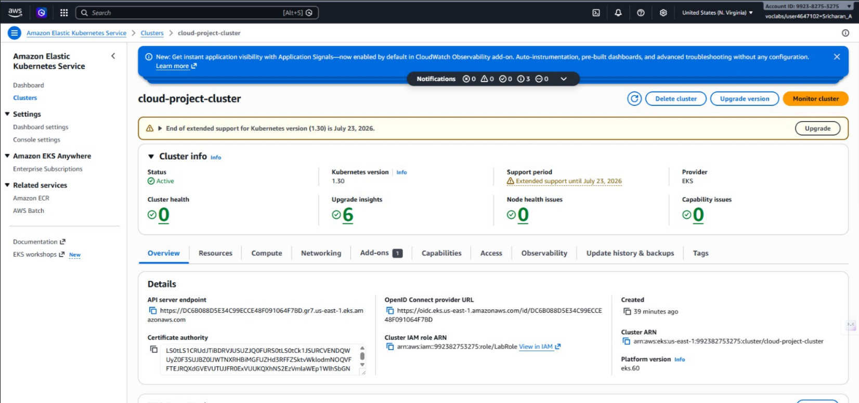

EC2 Instance :

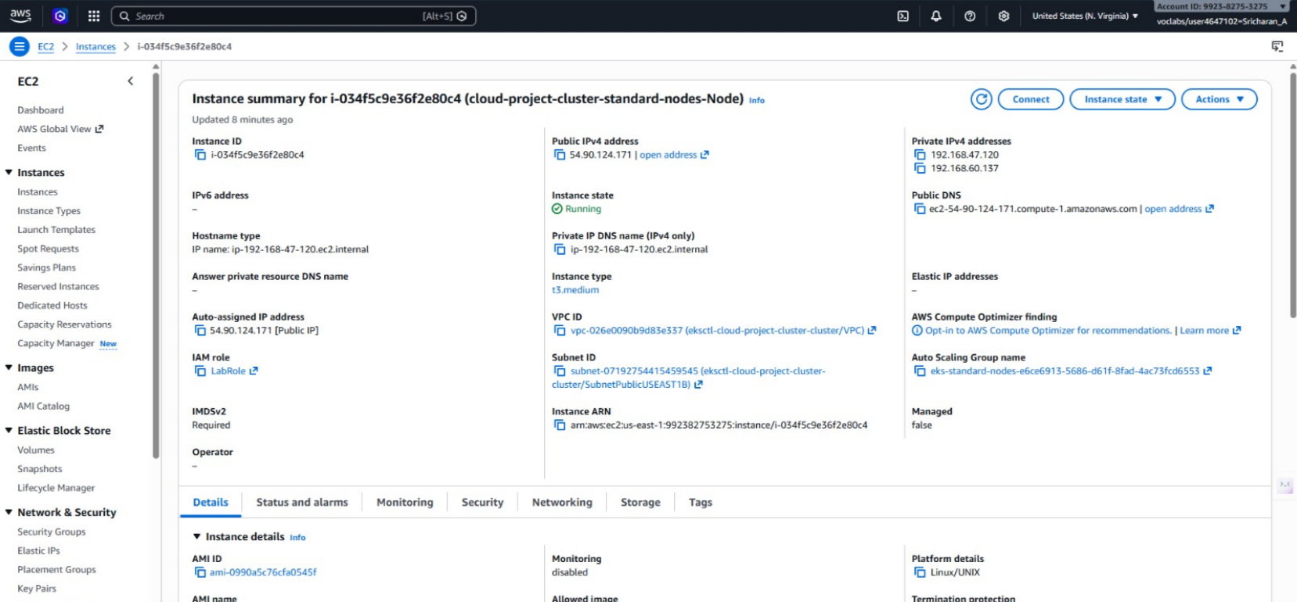

Load Balancer :

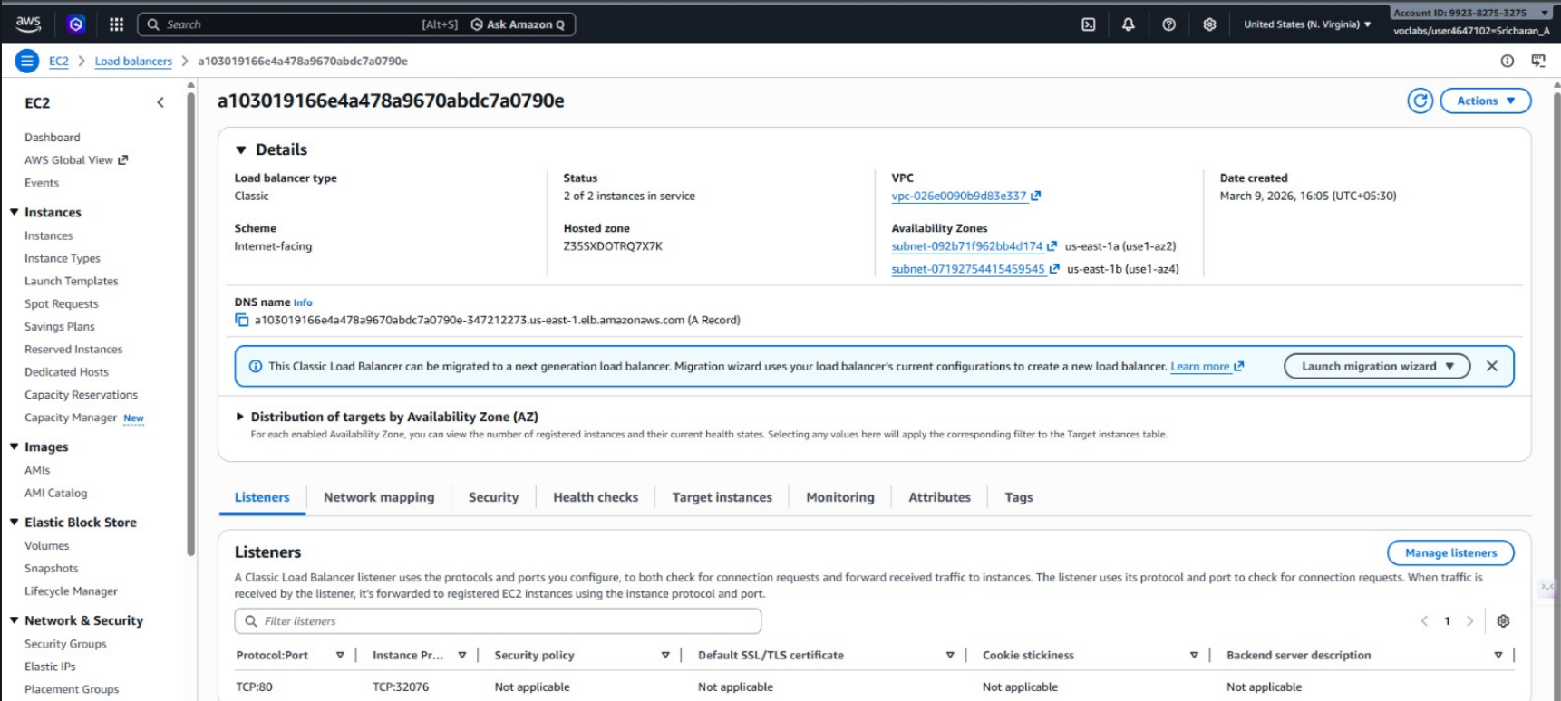

Project Frontend :

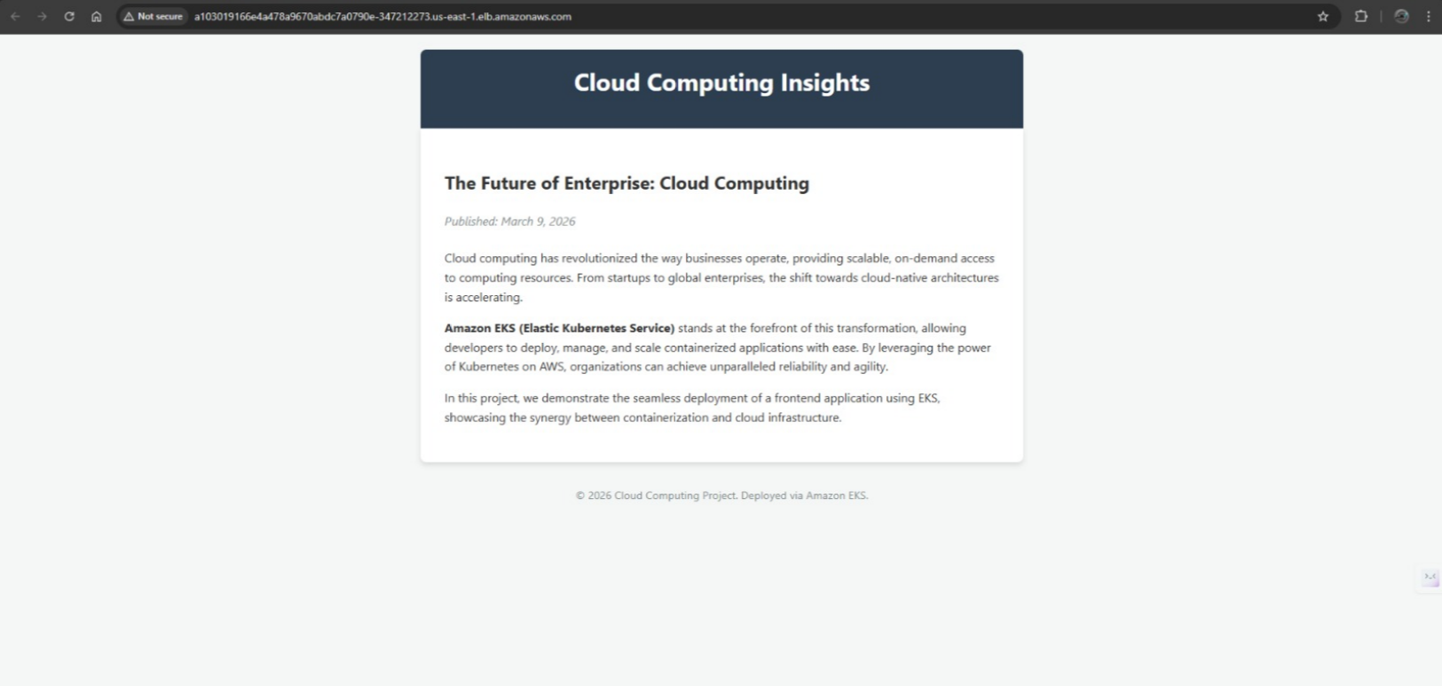

Docker Desktop :

